**MINI PROJECT REPORT**

**on**

**dResume**

**Submitted as partial fulfillment of**

**MASTER OF COMPUTER APPLICATION**

**DEGREE**

**SESSION 2023-24**

**By**

**Yash Gupta**

**2200320140198**

**Under the guidance of**

**Mr. Asheesh Pandey**

**Assistant Professor**

**ABES ENGINEERING COLLEGE, GHAZIABAD (032)**



**AFFILIATED TO**

**Dr. A.P.J ABDUL KALAM TECHNICAL UNIVERSITY, UTTAR PRADESH LUCKNOW**

Ref. No.:- ABES/ MCA /2023-24/001 Date: DD/MM/YYYY

**TO WHOMSOEVER IT MAY CONCERN**

This is to certify that Mini Project bearing title "dResume" is a bonafide record of project work done successfully by Mr./ Ms. Yash Gupta (2200320140198) of MCA-III semester under my supervision in partial fulfillment for the award of the degree in Master of computer Application from Dr. A.P.J. Abdul Kalam Technical University, Lucknow during the session 2023-24.

Mr. Asheesh Pandey

AssistantProfessor

Prof.(Dr.) Devendra Kumar

Internal Guide Head of Department

MCA Dept. MCA Dept

**STUDENT DECLARATION**

I hereby declare that the work being presented in this report entitled “**dResume”** is an authentic record of my own work carried out under the supervision of **“Asheesh Pandey”.**

#### Date: Signature of Student

**Yash Gupta**

This is to certify that the above statement made by the candidate is correct to the best of my knowledge.

#### Signature of HOD Signature of Internal Prof.( Dr.) Devendra Kumar Asheesh Pandey HOD-MCA AssistantProfessor

**Date:**

## ACKNOWLEDGEMENT

Any software project is not a work of an individual. It combines effort, ideas, suggestions, reviews, and hard work. I thank all who initiated and helped us to complete my project. One of the most pleasing aspects of collecting the necessary information and compiling it is the opportunity to thank those who have actively contributed to it.

I would like to thank my guide for his/her guidance and cooperation render for following me to undergo training under his/her guidance; I am also thanks to all the other college staff who helped me despite their busy schedule.

My special thanks to **Mr. Asheesh Pandey , Assistant Professor** for his active support, affectionate, guidance and constant encouragement.

I am highly indebted to **Prof. (Dr.) Devendra Kumar (HOD-MCA)** for his continuous effort in building a good infrastructure and developing a professional attitude within ourselves during the academic period of MCA (Master of Computer Application).

#### Signature of Student

**Yash Gupta**

**2200320140198 MCA-III Semester**

## ABSTRACT

The existing system is creating resumes manually either by using word or Google doc so there are some issues with the existing system. The existing system was suffering from a series of drawbacks. Since the whole of the system was to be maintained with the process of keeping, maintaining and retrieving the information was very tedious and lengthy. The records were never used to be in a systematic order there used to be lots of difficulties in associating any particular transaction with a particular context.If any information  was to be found  it was  required  to go  through  the  different registers, documents there would  never exist anything like report generation There would always be unnecessary consumption of time while entering records and retrieving records One more problem was that it was very difficult to find errors while entering the records Once the records were entered it was very difficult to update these records

**TABLE OF CONTENT**

|  |  |  |  |  |
| --- | --- | --- | --- | --- |
| **Sr.**  **No.** | **Content** | | | **Page No.** |
| 1. | Introduction | | | 1 |
|  | 1.1 | Objective | | 2 |
|  | 1.2 | Problem Statement | | 3 |
|  | 1.3 | Problem Definition | | 4 |
| 2. | Feasibility Study | | | 5 |
|  | 2.1 | | Technical | 5 |
|  | 2.2 | | Operational | 5 |
|  | 2.3 | | Economic | 5 |
|  | 2.4 | | Cost Estimation | 6 |
| 3 | Requirements | | | 7 |
|  | 3.1 | Technologies Used | | 8 |
|  | 3.2 | Functional Requirements | | 10 |
|  | 3.3 | Non-Functional Requirements | | 11 |
| 4 | Design | | | 12 |
|  | 4.1 | Model View Controller(MVC) Diagram | | 12 |
|  | 4.2 | ER-Diagram | | 13 |
|  | 4.3 | Data Flow Diagram(Zero Level DFD) | | 14 |
|  | 4.4 | Use Case | | 15 |
|  | 4.5 | Class Diagram | | 16 |
|  | 4.6 | Deployment Diagram | | 17 |
| 5 | GUI | | | 18 |
|  | 5.1 | | Modules Screenshot | 22 |
| 6 | Coding | | | 22 |
| 7 | Timeline of Project | | | 64 |
| 8 | Gantt Chart | | | 65 |

|  |  |  |
| --- | --- | --- |
| 9 | Future Scope | 66 |
| 10 | Conclusion | 67 |
| 10 | References | 68 |

## LIST OF FIGURES

|  |  |  |
| --- | --- | --- |
| **S. No.** | **Topic** | **Page No.** |
| Figure-1 | MVC Diagram | 5 |
| Figure-2 | ER-Diagram | 9 |
| Figure-3 | 0 level DFD | 9 |
| Figure-4 | Use Case Diagram | 10 |
| Figure-5 | Class Diagram |  |
| Figure-6 | Deployment Diagram |  |

**LIST OF TABLES**

|  |  |  |
| --- | --- | --- |
| **S. No.** | **Topics** | **Page No.** |
| Table-1 | Timeline of Project | 15 |
| Table -2 | Gantt Chart | 19 |

# ONLINE RESUME BUILDER

### INTRODUCTION

Resume is the first meeting between you and a prospective employer more often now than ever. So, how do you want to be remembered ? Wrinkled and unorganized. Neat and structured. Long and boring. Precise and interesting.Companies do not have the time to interview every applicant that is interested in the job. If they did, there would not be a company to work for. They use an eliminating process. That's right - resumes. When a job seeker wants to apply for a job online then generally he/she needs to attach his/her resume with the email.Online Resume Building System provides the users the popular resume formats & a better way to show their resumes to the employers. A job seeker does not need to attach a resume with every email, he/she just have to include the URL of his/her resume and the employer can view the resume online by clicking on the link and can download as well.

### 

### OBJECTIVE

The purpose of this online resume builder is to assist users in producing a professional resume for themselves. Candidates do not need to invest additional time in planning and creating a polished CV. They can instantly enter their information into the pop-up box, and a resume will be generated for them with a nice layout.

### Problem Statement:

The existing system is creating resumes manually either by using word or Google doc so there are some issues with the existing system. The existing system was suffering from a series of drawbacks. Since the whole of the system was to be maintained with the process of keeping, maintaining and retrieving the information was very tedious and lengthy. The records were never used to be in a systematic order there used to be lots of difficulties in associating any particular transaction with a particular context.If any information  was to be found  it was  required  to go  through  the  different registers, documents there would  never exist anything like report generation There would always be unnecessary consumption of time while entering records and retrieving records One more problem was that it was very difficult to find errors while entering the records Once the records were entered it was very difficult to update these records.

### Aims & Objectives:

The purpose of this online resume builder is to assist users in producing a professional resume for themselves. Candidates do not need to invest additional time in planning and creating a polished CV. They can instantly enter their information into the pop-up box, and a resume will be generated for them with a nice layout.

#### Problem Definition

* Project is related to Online Resume Building.
* This project maintains 3 types of users.
* Administrator User
* Users(Customers)
* Facilities provided by this projects are as follows
  + Details of customers are recorded.
  + Updating of data is easy.
  + Flow of information is fast and easy.
  + Customers can login to their accounts and view &update their data.
  + Notifications about resume views & downloads

### 

### FEASIBILITY STUDY

At this stage, the analyst estimates the urgency of the project and estimates the development cost.

In feasibility analysis, we have to study the following:

#### l) Technical Feasibility:

Technical feasibility is concerned with the availability of hardware and software required for the development of the system, to see compatibility and maturity of the technology proposed to be used and to see the availability of the required technical manpower to develop the system. After the study we came to conclusion that we proceed further with the tools and development environment chosen by us. This was important in our case as we were working on two various phases of the department that will need to be integrated in future to make an extended system.

#### Operational Feasibility:

Operational feasibility is all about problems that may arise during operations. There are two aspects related with this issue:

* + What is the probability that the solution developed may not put to use or may not work?
  + What is the inclination of the management and end users towards the solution? Though, there is very least possibility of management being averse to the solution, there is a significant probability that the end users may not be interested in using the solution due to lack of training, insight etc.

#### Economic Feasibility:

It is the measure of cost effectiveness of the project. The economic feasibility is nothing but judging whether the possible benefit of solving the problems is worthwhile of not. At the feasibility study level, it is impossible to estimate the cost because member's requirements and alternative solutions have not been identified at this stage. However, when the specific requirements and solutions have been identified, the analyst weighs the cost and benefits of all solutions, this is called "cost benefit analysis.

### COST ESTIMATION

Software cost comprises a small percentage of overall computer- based system cost. There are a number of factors, which are considered, that can affect the ultimate cost of the software such as - human, technical, Hardware and Software availability etc. The main point that was considered during the cost estimation of project was its sizing. In spite of complete software sizing, function point and approximate lines of code were also used to "size" each element of the Software and their costing. The cost estimation done by me for Project also depend upon the baseline metrics collected from past projects and these were used in conjunction with estimation variables to develop cost and effort projections.

We have basically estimated this project mainly on two bases -

1)Effort Estimation - This refers to the total man-hours required for the development of the project. It even includes the time required for doing documentation and user manual.

2)Hardware Required Estimation - This includes the cost of the PCs and the hardware cost required for development of this project.

#### Requirement Analysis

**User Registration and Authentication:**

* Users should be able to create accounts with a valid Username and password.
* Secure authentication mechanisms should be implemented to protect user accounts.

**Portfolio:**

* Users can add and show their Reviews..

**Blog**:

* Users can create and edit their posts on the blog.

**Contact:**

* Users can contact the person by filling the contact Form.

**Key Skills:**

* The User can showcase his key skills and edit them.

**Coding Skills:**

* The user can show and edit his Coding Skills.

**Performance:**

* The website should handle a specified number of concurrent users without performance degradation.

**Security:**

* User Details must be stored Safely.

**Usability:**

* The website should have an intuitive and responsive design for a positive user experience.

#### Technologies Used:

* + **HTML:**

The Hyper Text Mark-up Language or HTML is the standard mark-up language for documents designed to be displayed in a web browser. It can be assisted by technologies such as Cascading Style Sheets and scripting languages such as JavaScript.

#### CSS:

Cascading Style Sheets is a style sheet language used for describing the presentation of a document written in a mark-up language such as HTML or XML. CSS is a cornerstone technology of the World Wide Web, alongside HTML and JavaScript.

* + **Django:**

Django is a high-level Python web framework that encourages rapid development and clean, pragmatic design. Built by experienced developers, it takes care of much of the hassle of web development, so you can focus on writing your app without needing to reinvent the wheel. It’s free and open source.

* + **Python:**

Python is a high-level, general-purpose programming language. Its design philosophy emphasizes code readability with the use of significant indentation. Python is dynamically typed and garbage-collected. It supports multiple programming paradigms, including structured, object-oriented and functional programming.

* + **Text Editor or VS-code:**

A text editor is a type of computer program that edits plain text. Such programs are sometimes known as "notepad" software.

#### Functional Requirements

**User Registration and Authentication:**

* Users should be able to create accounts with a valid Username and password.
* Secure authentication mechanisms should be implemented to protect user accounts.

**Portfolio:**

* Users can add and show their Reviews..

**Blog**:

* Users can create and edit their posts on the blog.

**Contact:**

* Users can contact the person by filling the contact Form.

**Key Skills:**

* The User can showcase his key skills and edit them.

**Coding Skills:**

* The user can show and edit his Coding Skills.

#### Non-Functional Requirements:

**Performance:**

* The website should handle a specified number of concurrent users without performance degradation.

**Security:**

* User Details must be stored Safely.

**Usability:**

* The website should have an intuitive and responsive design for a positive user experience.

**DESIGN PHASE**

**MVC (Model View Controller Flow) Diagram**

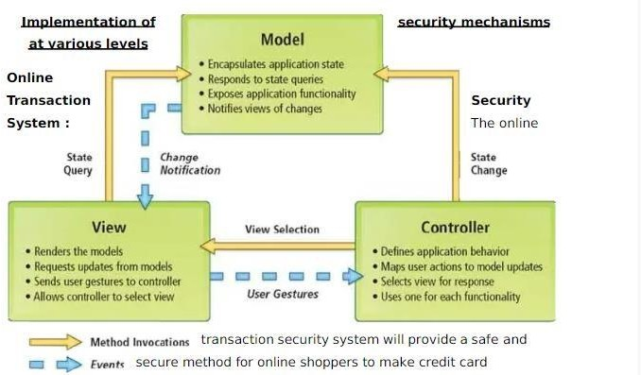

### ER-DIAGRAM

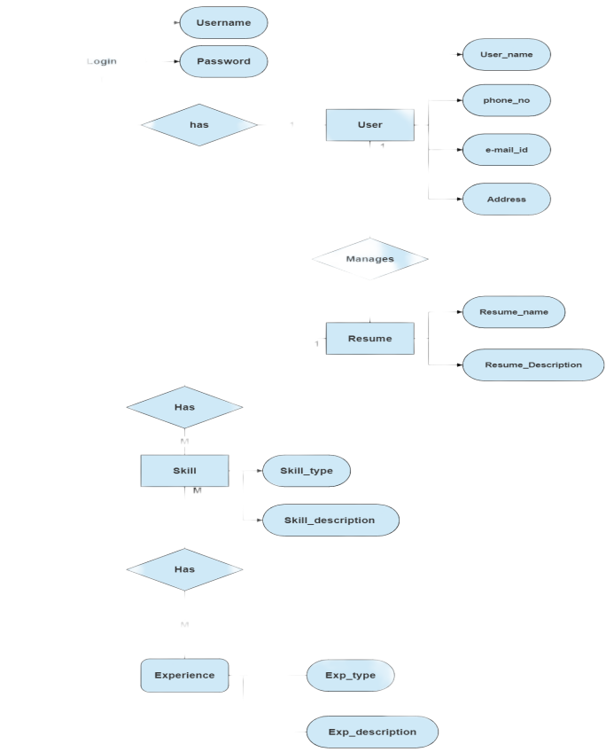

**Zero Level DFD**

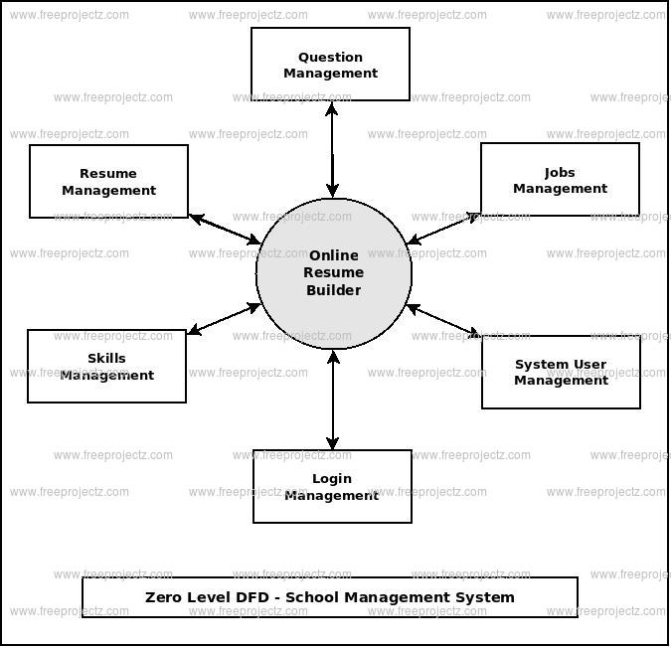

### USE CASE DIAGRAM

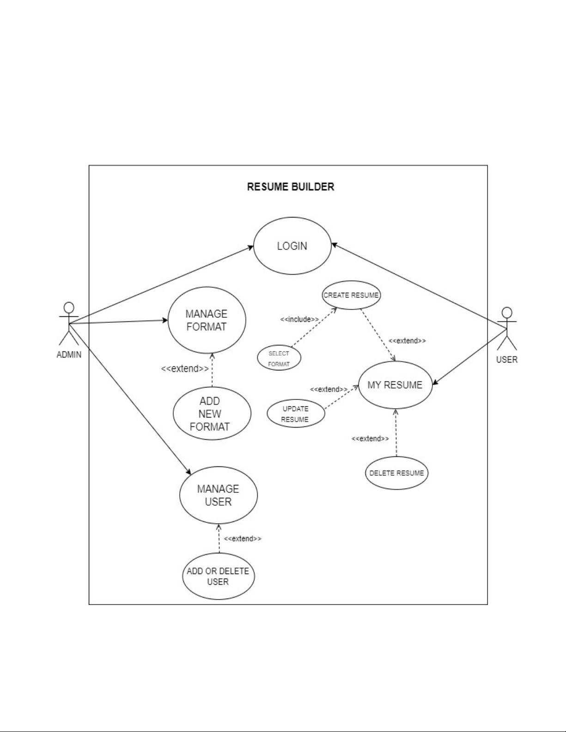

**CLASS DIAGRAM**

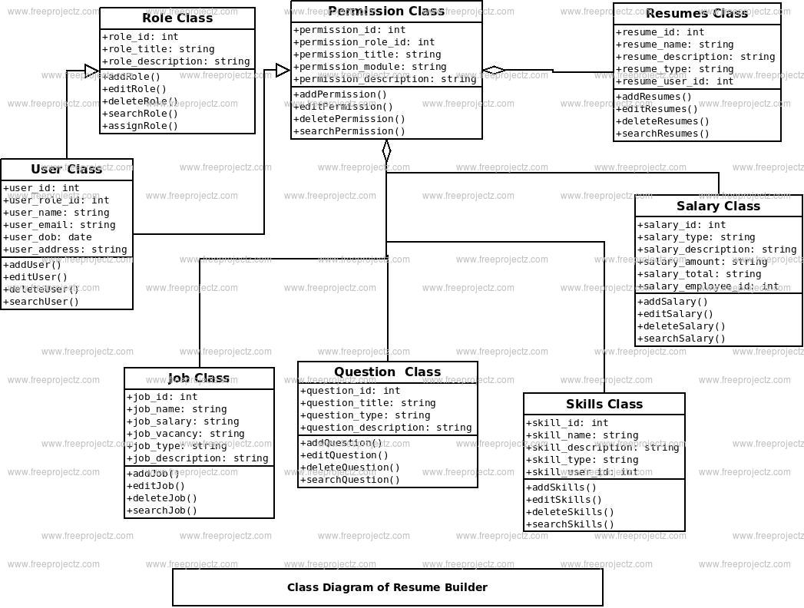

### DEPLOYMENT DIAGRAM

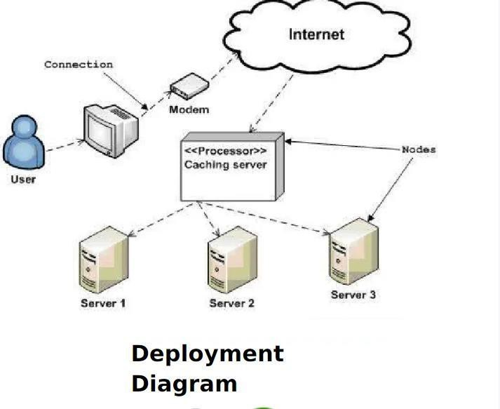

#### GUI

**Modules Screenshot**

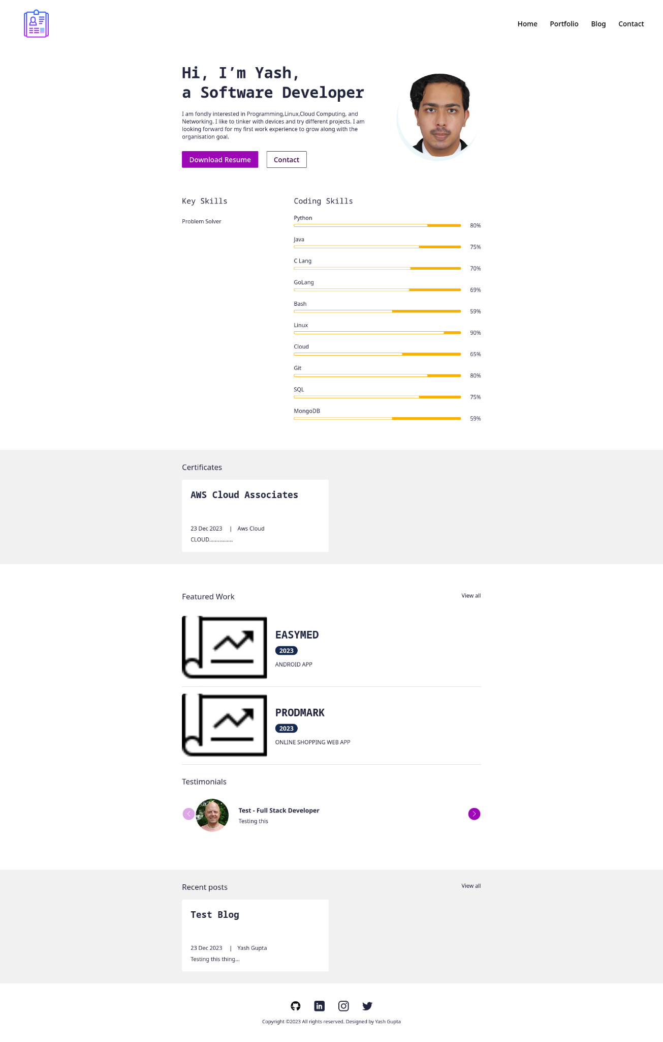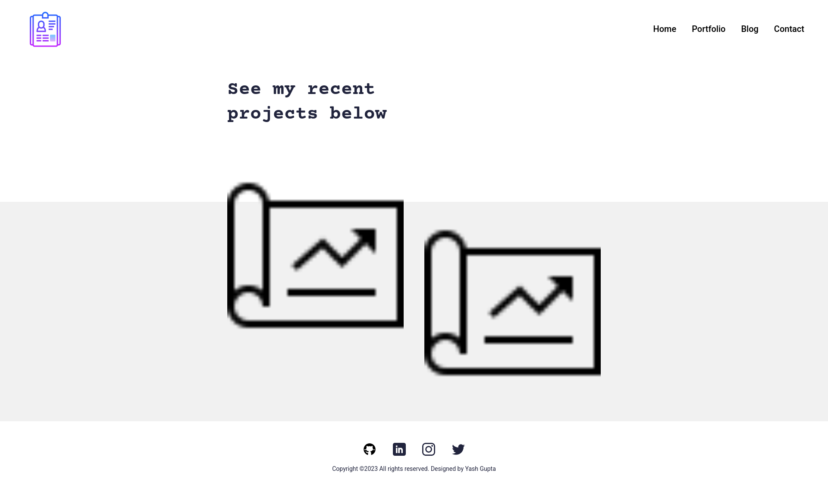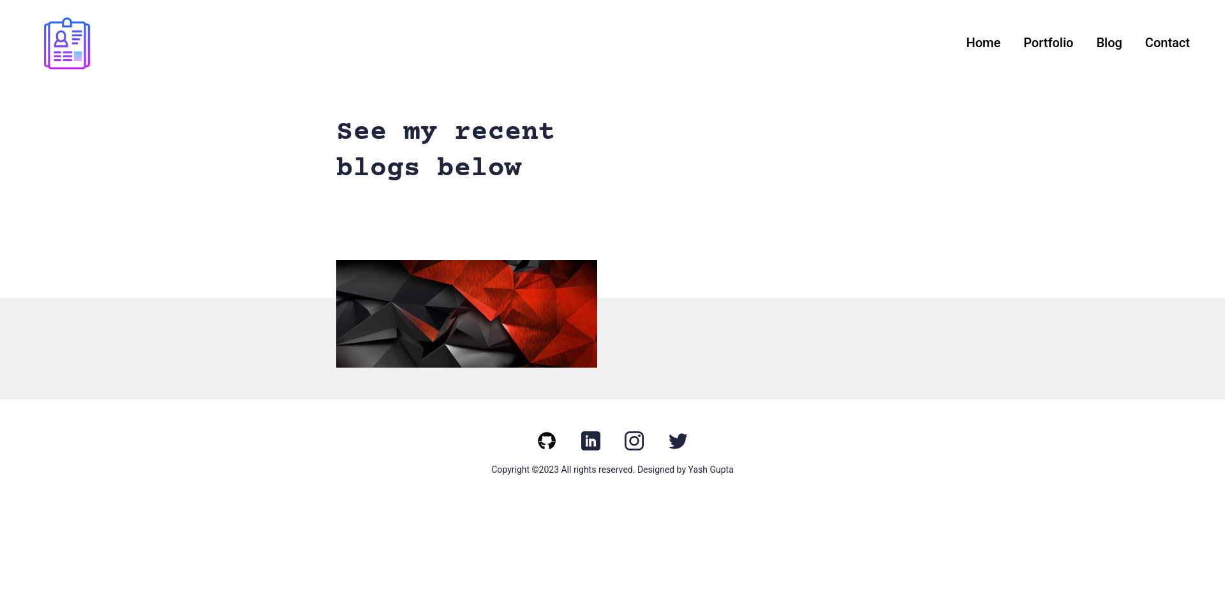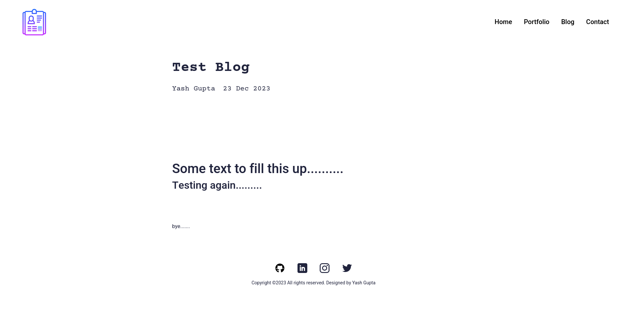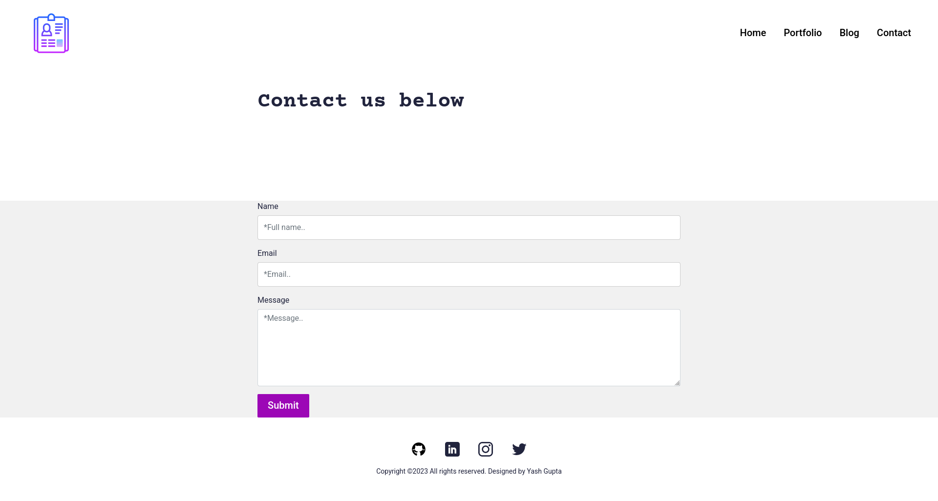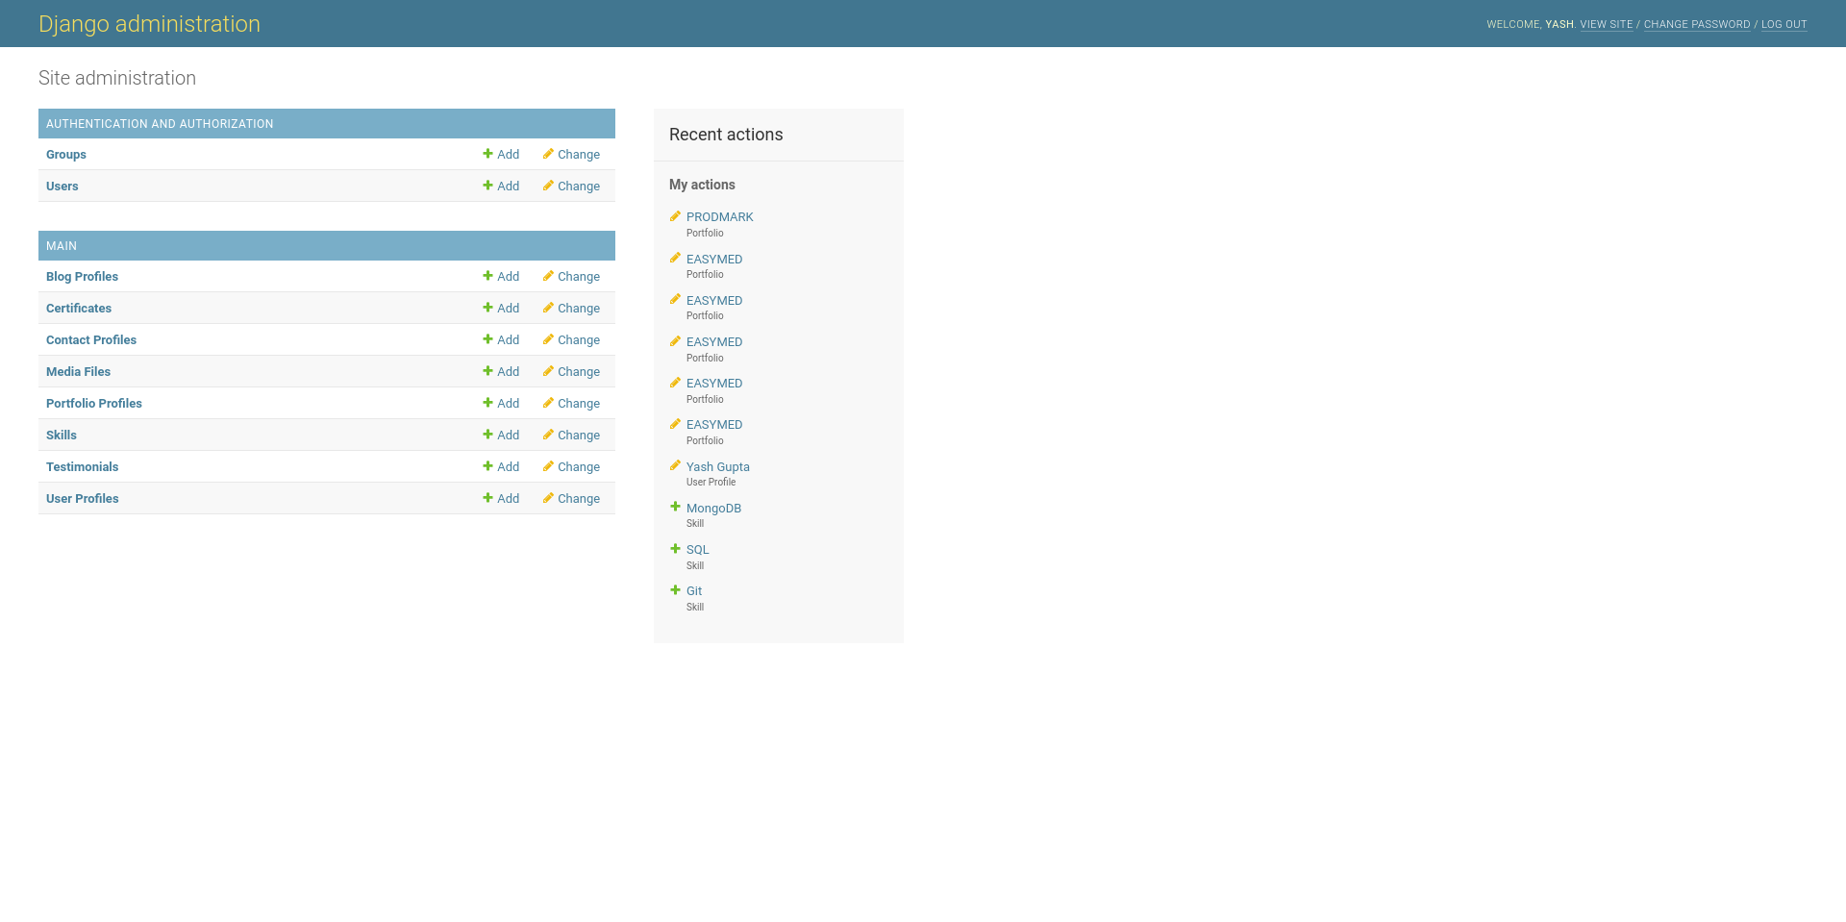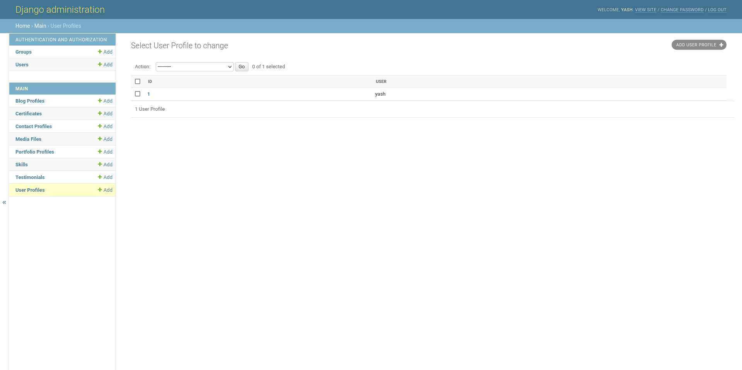

#### CODING PHASE

#### **HTML**

#### Base.html

#### {% load static %}

#### <!doctype html>

#### <html lang="en">

#### <head>

#### <meta charset="utf-8">

#### <meta name="viewport" content="width=device-width, initial-scale=1">

#### <title>{% block title %}{%endblock %}</title>

#### <meta name="author" content="Did Coding Limited & James Granger Design">

#### <link rel="canonical" href="{{request.path}}"/>

#### <link rel="home" href="{% url 'main:home' %}"/>

#### <meta name="description" content="{% block description %}{% endblock %}">

#### <meta name="keywords" content="{% block keywords %}{% endblock %}">

#### <link rel="shortcut icon" type="image/x-icon" href="{% static 'images/icon.jpg' %}">

#### <link rel="apple-touch-icon" type="image/jpg" href="{% static 'images/icon.jpg' %}">

#### <!-- ================================

#### Start CSS

#### ================================= -->

#### <link href="{% static 'css/bootstrap.min.css' %}" rel="stylesheet">

#### <link rel="stylesheet" href="https://unpkg.com/swiper@7.0.5/swiper-bundle.min.css">

#### <link href="{% static 'css/style.css' %}" rel="stylesheet">

#### {% block extend_header%}{%endblock%}

#### <!-- ================================

#### End CSS

#### ================================= -->

#### </head>

#### <body>

#### {% include 'main/partials/messages.html' %}

#### {% include 'main/partials/nav.html' %}

#### {% block content %}

#### {% endblock %}

#### {% include 'main/partials/footer.html' %}

#### <!-- ================================

#### Start Scripts

#### ================================= -->

#### <script src="https://cdnjs.cloudflare.com/ajax/libs/jquery/3.6.0/jquery.min.js"></script>

#### <script src="{% static 'js/bootstrap.bundle.min.js' %}"></script>

#### <script src="https://unpkg.com/swiper@7.0.5/swiper-bundle.min.js"></script>

#### <script src="{% static 'js/script.js' %}"></script>

#### {% block extend_footer %}{%endblock%}

#### <!-- ================================

#### End Scripts

#### ================================= -->

#### </body>

#### </html>

#### **Blog.html**

#### {% extends 'main/base.html' %}

#### {% load static %}

#### <!-- ================================

#### Start SEO blocks

#### ================================= -->

#### {% block title %}{% endblock %}

#### {% block decription %}{% endblock %}

#### {% block keywords %}{% endblock %}

#### <!-- ================================

#### END SEO blocks

#### ================================= -->

#### <!-- ================================

#### Start CSS blocks

#### ================================= -->

#### {% block extend_header %}{% endblock %}

#### <!-- ================================

#### END CSS blocks

#### ================================= -->

#### <!-- ================================

#### Start script blocks

#### ================================= -->

#### {% block extend_footer %}{% endblock %}

#### <!-- ================================

#### END script blocks

#### ================================= -->

#### <!-- ================================

#### Start Content

#### ================================= -->

#### {% block content %}

#### <section>

#### <div class="innerPageBannerCol">

#### <div class="container">

#### <div class="row g-4 g-md-3 align-items-center">

#### <div class="col-md-6">

#### <div class="bannerContent">

#### <h1 class="xlTitle pb-md-3">See my recent blogs below</h1>

#### </div>

#### </div>

#### </div>

#### </div>

#### </div>

#### </section>

#### <section>

#### <div class="lightBg">

#### <div class="container">

#### <div class="portfolioContentMain">

#### <div class="row g-3 g-md-4 g-lg-5 portfolioRow">

#### {% for obj in object_list %}

#### <div class="col-md-6 pColMain">

#### <div class="pCol">

#### <a href="{% url 'main:blog' slug=obj.slug %}" >

#### <img src="{{obj.image.url}}" alt="..." class="pImg">

#### </a>

#### </div>

#### </div>

#### {% endfor %}

#### </div>

#### </div>

#### </div>

#### </div>

#### </section>

#### <!-- ================================

#### End Content

#### ================================= -->

#### {%endblock%}

#### 

#### **Python**

#### **Urls.py**

#### from django.contrib import admin

#### from django.urls import path, include

#### from django.conf import settings

#### from django.conf.urls.static import static

#### from django.views.static import serve

#### from django.conf.urls import url

#### urlpatterns = [

#### path('admin/', admin.site.urls),

#### path('', include('main.urls', namespace="main")),

#### url(r'^media/(?P<path>.*)$', serve,

#### {'document_root': settings.MEDIA_ROOT}),

#### url(r'^static/(?P<path>.*)$', serve,

#### {'document_root': settings.STATIC_ROOT}),

#### ]

#### if settings.DEBUG:

#### urlpatterns += static(settings.STATIC_URL, document_root=settings.STATIC_ROOT)

#### urlpatterns += static(settings.MEDIA_URL, document_root=settings.MEDIA_ROOT)

### Timeline of the project:

|  |  |
| --- | --- |
| **Project Life cycle** | **Timeline** |
| **Initiating/Defining** | Completed |
| **Planning/Designing** | Completed |
| **Executing/Coding** | Completed |
| **Closing** | Processing |

**Gantt Chart:**

|  |  |  |  |  |
| --- | --- | --- | --- | --- |
|  | Week1 | Week2 | Week3 | Week4 |
| Phase 1 | **Initiating** | **Planning** | **Defining** | **Need** |
| Phase 2 | **Requirement** | **Blue Print** | **Designing** | **Building** |
| Phase 3 | **Front end** | **Development** | **Back end** | **Development** |
| Phase 4 | **Testing** | **Validating** | **Verifying** | **Deploying** |

### Benefits of Online Resume Builder:

* Save time
* Resume templates can help you save time by allowing you to focus on personalizing details.
* Display achievements
* Resume builders can help you display your achievements, skills, and certifications at a glance.
* Consistent Information

Digital Resume provides a consistent and accurate information based on the data they are programmed with, reducing the chances of human errors in conveying details.

### Scope for the project Digital Resume:

Online Resume Builder can be used in accordance with the

requirements of the customers. Customers can customize their

resumes with their choice of themes & details. The services are

hard to be defeated by the competitors as the system is

providing the customers exactly what they want.

### CONCLUSION

In conclusion, the online resume builder is one of the most fantastic systems for the people who are either freshers in their domain or if they don’t have enough idea about the resume or don’t have enough time to create the resume of good designs or patterns, then this platform is a very productive place for them. It saves a lot of time and cost-effective. As technology continues to evolve, this project stands as a testament to the potential of innovative solutions in simplifying the college selection process, ultimately benefiting the users.

#### REFERENCES

* Wikipedia.org
* [www.w3schools.com](http://www.w3schools.com/)
* Software Engineering – R.S.Pressma
* JavaScript By McGraw hill Publication
* Youtube.com